DIRECTIONS & EXAMPLE
Directions for Degree-Granting Bridge Curriculum Map (Quality Indicator 4: Curriculum)
Courses Aligned with Graduate-Level Academic Competencies and Performance Indicators

Background: The Degree-Granting Bridge Curriculum Map is used to identify the courses where the competencies and performance indicators are incorporated in the curriculum through learning activities, assessment (e.g., projects, case studies, presentations, exams), and supervised practice, and covered in textbooks and coursework to prepare students to demonstrate the required competencies.

Directions:
- You may choose to complete the curriculum map using the Word document or the Excel Spreadsheet provided on the ACEND EARN Division Bridge webpage.
- List courses/rotations in chronological order, organized by academic term, including course number and course title.
- Next, using course syllabi, textbooks, assignments, projects, assessments, etc., identify performance indicators that are covered in the course/rotation, determine at which level (knows, shows, does) the performance indicator will be covered, and place either a “K”, “S” or “D” in the appropriate column and follow the directions below to color code the cell based on that level.
- All performance indicators associated with the academic competencies must be covered in the curriculum and identified on the curriculum map.
- For courses where a performance indicator is being covered several times and at various levels of performance, record the highest level to be covered or demonstrated in that course.
- The level of achievement of a performance indicator must be met in the curriculum at least once at the level specified for that performance indicator (or at a higher level) as indicated by the color coding in the first column. For example, if a performance indicator is at the “shows” level (yellow color), it must be covered at the “shows” or at the “does” level somewhere in the curriculum and be shown on the curriculum map. (See Example for PI 1.1.3)

Color Coding Cells Based on Expected level of Performance: Performance indicators are written such that the verb in each describes an expected level of performance, from knows the information to demonstrates the applied knowledge, skill and judgment (competence) in an artificial or real situation. Therefore, as a guide, in addition to placing an X or letter (K, S, D) in the cell, also color code the cell using this color scheme: Blue: Knows the required knowledge. Beige: Shows they can apply the required knowledge, skill and judgment in an artificial or work situation. Green: Performs or Does the described action in an artificial or work situation.

EXAMPLE

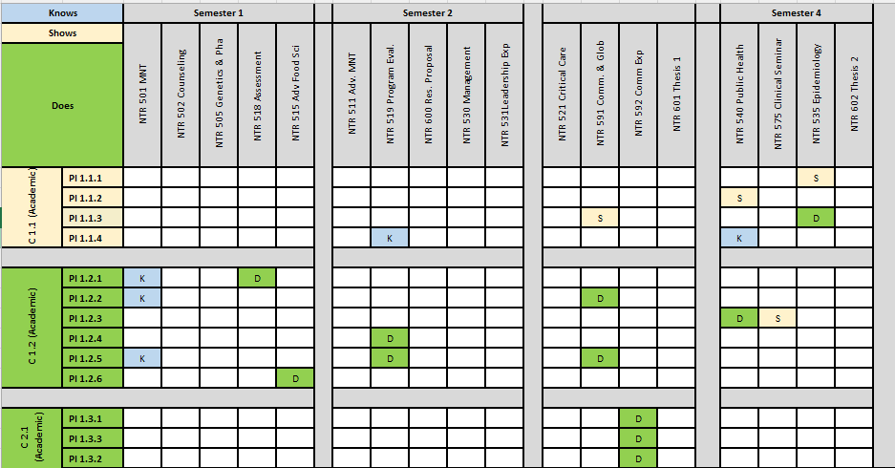

<Name of the Institution and Program Sponsoring the Bridge>
Degree-Granting Bridge Curriculum Map
Courses Aligned with Graduate-Level Academic Competencies and Performance Indicators

 |  | Semester 1 |  |  |  |  | Semester 2 |  |  |  |  | Semester 3 |  |  |  |  | Semester 4 |  |  |  |  | Semester 5 |  |  |  |  | Semester 6
  Knows
Shows |  | Course | Course | Course | Course | Course | Course | Course | Course | Course | Course | Course | Course | Course | Course | Course | Course | Course | Course | Course | Course | Course | Course | Course | Course | Course | Course | Course | Course | Course | Course
Does
C 1.1  (Academic) | PI 1.1.1
C 1.1  (Academic) | PI 1.1.2
C 1.1  (Academic) | PI 1.1.3
C 1.1  (Academic) | PI 1.1.4
C 1.2  (Academic) | PI 1.2.1
C 1.2  (Academic) | PI 1.2.2
C 1.2  (Academic) | PI 1.2.3
C 1.2  (Academic) | PI 1.2.4
C 1.2  (Academic) | PI 1.2.5
C 1.2  (Academic) | PI 1.2.6
C 2.1  (Academic) | PI 2.1.1
C 2.1  (Academic) | PI 2.1.2
C 2.5  (Academic) | PI 2.5.1
C 2.5  (Academic) | PI 2.5.2
C 2.5  (Academic) | PI 2.5.3
C 2.5  (Academic) | PI 2.5.4
C 2.8  (Academic) | PI 2.8.1
C 2.8  (Academic) | PI 2.8.2
C 2.8  (Academic) | PI 2.8.3
C 3.3  (Academic) | PI 3.3.1
C 3.3  (Academic) | PI 3.3.2
C 3.5  (Academic) | PI 3.5.1
C 3.5  (Academic) | PI 3.5.2
C 3.5  (Academic) | PI 3.5.3
C 3.5  (Academic) | PI 3.5.4
C 3.5  (Academic) | PI 3.5.5
C 3.5  (Academic) | PI 3.5.6
C 3.5  (Academic) | PI 3.5.7
C 3.8  (Academic) | PI 3.8.1
C 3.8  (Academic) | PI 3.8.2
C 3.8  (Academic) | PI 3.8.3
C 3.8  (Academic) | PI 3.8.4
C 5.1  (Academic) | PI 5.1.1
C 5.1  (Academic) | PI 5.1.2
C 6.1  (Academic) | PI 6.1.1
C 6.1  (Academic) | PI 6.1.2
C 6.1  (Academic) | PI 6.1.3
C 6.1  (Academic) | PI 6.1.4
C 6.1  (Academic) | PI 6.1.5
C 6.1  (Academic) | PI 6.1.6
C 6.1  (Academic) | PI 6.1.7

