Directions for Continuous Program Improvement Plan (Required Element 2.3)

Background: The Continuous Program Improvement Plan (CPIP) is used to document the strengths and areas for improvement of the program identified through the program evaluation process and strategies that the program plans to implement to maintain program strengths and address areas for improvement. All programs must have a Continuous Program Improvement Plan. Strengths, areas for improvement and strategies that are in progress from the 2017 Standards CPIP should be carried over from the 2017 CPIP and documented in the 2022 CPIP
Directions:
Using the table below:
- In column b, list strengths and areas for improvement resulting from the program evaluation process relative to the components listed in the table below. Include any additional strengths or areas for improvement by adding rows to the bottom of the table. In column a, indicate the year it was identified.
Directions &
Examples
Directions &
Examples
  - If one-year pass rate is below the benchmark (80% RDN/70% NDTR over a three-year period as indicated in the Pearson VUE report) this should be listed as an area for improvement; and short- and long-term strategies to address this must be described. Consider including strategies for addressing admission requirements, academic counseling, credentialing exam preparation, and other areas that could impact pass rate under the appropriate component in the table.
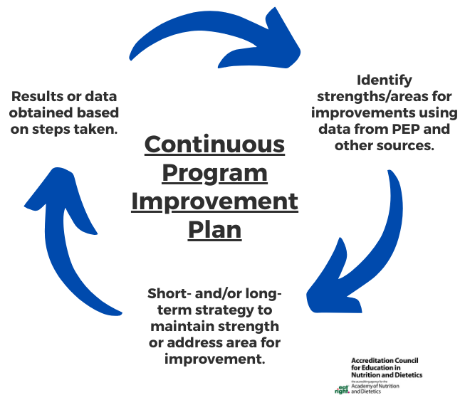
- In column c, include the outcomes of the objectives in the Program Evaluation Plan (PEP) and other sources to indicate how the program has identified strengths and areas for improvement. Any program objective that is not met is considered an area for improvement and must be addressed.
- In column d, include short- or long-term strategies to maintain strengths or address areas for improvement with an implementation timeline. A short-term strategy is one that will be completed within three years. A long-term strategy is anything greater than three years.
- In column e, update the results or data provided in column c, if available, based on the implementation of the short- and long-term strategies. (Note that the continuous program improvement process is a circular process where the results in column e inform the program whether its strategies are effective.) If any rows below do not apply to your program or program type, please type “N/A”.

EXAMPLE

Policies and Procedures
- Year  Identified | b) Identify strengths and/or areas for improvement resulting from the program evaluation process | c) Data from PEP and other sources used to identify this strength or area for improvement | d) Short- or long-term strategy to maintain strength or address area for improvement (with timeframe for implementing strategies) (Note: Continue is not a timeframe) | e) Results or data obtained based on steps taken to date.
2021 | Improvement Needed:  Remediation policy revision and update | Incomplete remediation policy noted when a student presented with tardiness issues in food lab  Directions &  Examples | - Discuss issue with department’s Students Affairs Committee and revise policy regarding issues that call for remediation and the steps to take (Spring 2021)  - Determine after policy is implemented whether additional revisions are required | 1.a. Announced in all Fall 2021 departmental courses the need for an advising appointment in Spring Semester prior to Fall Semester course registration  1.b. Added revised policy to student handbook for Fall 2021 distribution  2. Place on Spring 2022 and 2023 Students Affairs Committee agendas to determine if remediation policy was used again and whether it was successful in dealing with the issues
2023 | Strength: Program Policies and Procedures reviewed annually | Program director and advisory committee review data annually from the program evaluation plan and graduate exit surveys to review the need for updates to all policies | Hold meetings every June to review available data and improve policies to ensure transparency and clarity for enrolled students. Consistent agenda item for summer meeting to ensure the review of P&P takes place. | This annual review ensures policies are reviewed and revised in a timely manner and are current.
Curriculum
a) Year Identified | b) Identify strengths and/or areas for improvement resulting from the program evaluation process | c) Data from PEP and other sources used to identify this strength or area for improvement | d) Short- or long-term strategy to maintain strength or address area for improvement (with timeframe for implementing strategies) (Note: Continue is not a timeframe) | e) Results or data obtained based on steps taken to date.
2020 | Improvement Needed: Students sign up for courses out of sequence; course instructor drops students from course; student cannot register for required course because it is full | PEP program completion objective data 80% of students complete within 150% of program length:  2018-2020: 40/60 (67%) Not met | - Discuss issue with academic advisors and faculty (Invite advisors to faculty curriculum meeting Fall 2020)  - Introduce importance of following curriculum schedule to students in Intro to Dietetics course (Fall 2020)  Directions &  Examples  - Monitor program completion rate from PEP annually prior to Fall faculty curriculum meeting | Policies revised to require students meet with academic advisor each spring; Students informed that this requirement will be implemented spring 2021.  PEP program completion objective:  2019-2021: 70% (Not met)  2020-2022: Not Yet Available  2021-2023: Not Yet Available
2021 | Strength: Solid preparation for calculating nutritional needs for individuals throughout the lifespan that aids them in higher level coursework | Nutrition through the Lifecycle, Nutrition Assessment, Medical Nutrition Therapy Course Evaluations | Monitor course evaluations and student grades in the courses annually | Students indicate high level of comfort with calculating nutrient needs for individuals on course evaluations; Target not to fall below an average score of 4.8/6.0 in any of the three courses.  2021: 5.2 (Met)  2022: Not Yet Available  2023: Not Yet Available

<Name of your program goes here>
Continuous Program Improvement Plan (Required Element 2.3)
All Program Types
Date of Last Accreditation Site Visit Review ________________

Policies and Procedures
a) Year Identified | b) Identify strengths and/or areas for improvement resulting from the program evaluation process | c) Data from PEP and other sources used to identify this strength or area for improvement | d) Short- or long-term strategy to maintain strength or address area for improvement (with timeframe for implementing strategies) (Note: Continue is not a timeframe) | e) Results or data obtained based on steps taken to date
Curriculum
a) Year Identified | b) Identify strengths and/or areas for improvement resulting from the program evaluation process | c) Data from PEP and other sources used to identify this strength or area for improvement | d) Short- or long-term strategy to maintain strength or address area for improvement (with timeframe for implementing strategies) (Note: Continue is not a timeframe) | e) Results or data obtained based on steps taken to date
Teaching Methods
a) Year Identified | b) Identify strengths and/or areas for improvement resulting from the program evaluation process | c) Data from PEP and other sources used to identify this strength or area for improvement | d) Short- or long-term strategy to maintain strength or address area for improvement (with timeframe for implementing strategies) (Note: Continue is not a timeframe) | e) Results or data obtained based on steps taken to date
Faculty
a) Year Identified | b) Identify strengths and/or areas for improvement resulting from the program evaluation process | c) Data from PEP and other sources used to identify this strength or area for improvement | d) Short- or long-term strategy to maintain strength or address area for improvement (with timeframe for implementing strategies) (Note: Continue is not a timeframe) | e) Results or data obtained based on steps taken to date
Preceptors
a) Year Identified | b) Identify strengths and/or areas for improvement resulting from the program evaluation process | c) Data from PEP and other sources used to identify this strength or area for improvement | d) Short- or long-term strategy to maintain strength or address area for improvement (with timeframe for implementing strategies) (Note: Continue is not a timeframe) | e) Results or data obtained based on steps taken to date
Resources
a) Year Identified | b) Identify strengths and/or areas for improvement resulting from the program evaluation process | c) Data from PEP and other sources used to identify this strength or area for improvement | d) Short- or long-term strategy to maintain strength or address area for improvement (with timeframe for implementing strategies) (Note: Continue is not a timeframe) | e) Results or data obtained based on steps taken to date
Other
a) Year Identified | b) Identify strengths and/or areas for improvement resulting from the program evaluation process | c) Data from PEP and other sources used to identify this strength or area for improvement | d) Short- or long-term strategy to maintain strength or address area for improvement (with timeframe for implementing strategies) (Note: Continue is not a timeframe) | e) Results or data obtained based on steps taken to date

