DIRECTIONS & EXAMPLE
Directions for Supervised Practice Experience (SPE) Curriculum Map (Required Element 3.2)
Rotations Aligned with Competencies and Performance Indicators

Background: The Supervised Practice Experience Curriculum Map is used to identify the rotations where the competencies and performance indicators are incorporated in the curriculum through learning activities, assessment (e.g., projects, case studies, presentations, exams), and supervised practice and covered in textbooks and coursework to prepare students to demonstrate the required competencies.

Directions:
- List rotations in chronological order or by category. If the courses are included in the program, include course number and course title.
- Next, using rotation descriptions, textbooks, assignments, projects, assessments, etc., identify performance indicators that are covered in the rotation, determine at which level (knows, shows, does) the performance indicator will be covered, and place either a “K”, “S”, or “D” in the appropriate column and follow the directions below to color code the cell based on that level.
- All performance indicators must be covered in the curriculum and identified on the curriculum map.
- For rotations where a performance indicator is being covered several times and at various levels of performance, record the highest level to be covered or demonstrated in that rotation.
- The level of achievement of a performance indicator must be met in the curriculum at least once at the level specified for that performance indicator (or at a higher level) as indicated by the color coding in the first column. For example, if a performance indicator is at the “shows” level (yellow color), it must be covered at the “shows” or at the “does” level somewhere in the curriculum and be shown on the curriculum map. (See Example for PI 2.2.6)

Color Coding Cells Based on Expected level of Performance: Performance indicators are written such that the verb in each describes an expected level of performance, from knows the information to demonstrates the applied knowledge, skill and judgment (competence) in an artificial or real situation. Therefore, as a guide, in addition to placing an X or letter (K, S, D) in the cell, also color code the cell using this color scheme: Blue: Knows the required knowledge. Beige: Shows they can apply the required knowledge, skill and judgment in an artificial or work situation. Green: Performs or Does the described action in an artificial or work situation.

EXAMPLE
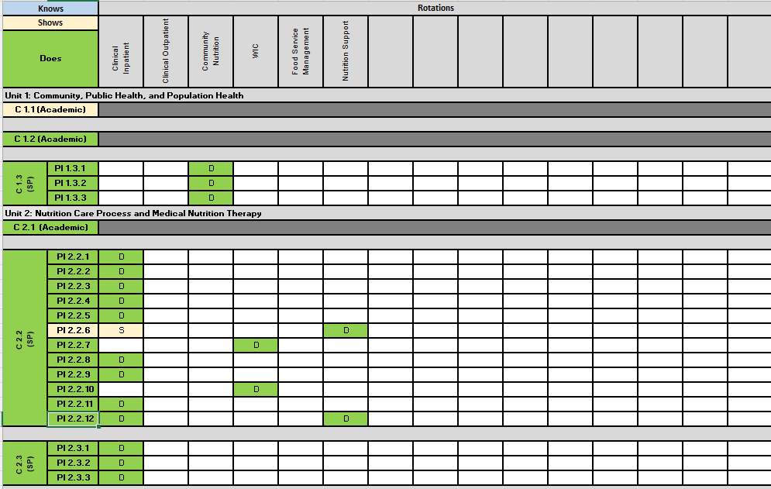

<Name of your program goes here>
Supervise Practice Experience (SPE) Curriculum Map (Required Element 3.2)
Rotations Aligned with Competencies and Performance Indicators

 |  | Rotation
  Knows
Shows |  | Rotation | Rotation | Rotation | Rotation | Rotation | Rotation | Rotation | Rotation | Rotation | Rotation | Rotation | Rotation | Rotation | Rotation | Rotation | Rotation | Rotation | Rotation | Rotation | Rotation | Rotation | Rotation | Rotation | Rotation | Rotation | Rotation | Rotation | Rotation | Rotation | Rotation
Does
C 1.1 (Academic)
C 1.2 (Academic)
C 1.3  (SP) | PI 1.3.1
C 1.3  (SP) | PI 1.3.2
C 1.3  (SP) | PI 1.3.3
C 2.1 (Academic)
C 2.2 (SP) | PI 2.2.1
C 2.2 (SP) | PI 2.2.2
C 2.2 (SP) | PI 2.2.3
C 2.2 (SP) | PI 2.2.4
C 2.2 (SP) | PI 2.2.5
C 2.2 (SP) | PI 2.2.6
C 2.2 (SP) | PI 2.2.7
C 2.2 (SP) | PI 2.2.8
C 2.2 (SP) | PI 2.2.9
C 2.2 (SP) | PI 2.2.10
C 2.2 (SP) | PI 2.2.11
C 2.2 (SP) | PI 2.2.12
C 2.3  (SP) | PI 2.3.1
C 2.3  (SP) | PI 2.3.2
C 2.3  (SP) | PI 2.3.3
C 2.4  (SP) | PI 2.4.1
C 2.4  (SP) | PI 2.4.2
C 2.4  (SP) | PI 2.4.3
C 2.4  (SP) | PI 2.4.4
C 2.5 (Academic)
C 2.6 (SP) | PI 2.6.1
C 2.6 (SP) | PI 2.6.2
C 2.6 (SP) | PI 2.6.3
C 2.6 (SP) | PI 2.6.4
C 2.6 (SP) | PI 2.6.5
C 2.7  (SP) | PI 2.7.1
C 2.7  (SP) | PI 2.7.2
C 2.7  (SP) | PI 2.7.3
C 2.7  (SP) | PI 2.7.4
C 2.7  (SP) | PI 2.7.5
C 2.8  (Acad & SP) | PI 2.8.1
C 2.8  (Acad & SP) | PI 2.8.2
C 2.8  (Acad & SP) | PI 2.8.3
C 3.1 | PI 3.1.1
C 3.1 | PI 3.1.2
C 3.1 | PI 3.1.3
C 3.1 | PI 3.1.4
C 3.1 | PI 3.1.5
C 3.1 | PI 3.1.6
C 3.2 (SP) | PI 3.2.1
C 3.2 (SP) | PI 3.2.2
C 3.2 (SP) | PI 3.2.3
C 3.2 (SP) | PI 3.2.4
C 3.2 (SP) | PI 3.2.5
C 3.2 (SP) | PI 3.2.6
C 3.3 (Academic)
C 3.4 (SP) | PI 3.4.1
C 3.4 (SP) | PI 3.4.2
C 3.4 (SP) | PI 3.4.3
C 3.4 (SP) | PI 3.4.4
C 3.4 (SP) | PI 3.4.5
C 3.5 (Academic)
C 3.6 (Academic)
C 3.7 (SP) | PI 3.7.1
C 3.7 (SP) | PI 3.7.2
C 3.7 (SP) | PI 3.7.3
C 3.8 (Academic)
C 4.1 (SP) | PI 4.2.1
C 4.1 (SP) | PI 4.2.2
C 4.1 (SP) | PI 4.2.3
C 5.1  (SP) | PI 5.1.1
C 5.1  (SP) | PI 5.1.2
C 5.2 (SP) | PI 5.2.1
C 5.2 (SP) | PI 5.2.2
C 5.2 (SP) | PI 5.2.3
C 5.2 (SP) | PI 5.2.4
C 5.2 (SP) | PI 5.2.5
C 5.2 (SP) | PI 5.2.6
C 5.2 (SP) | PI 5.2.7
C 5.3 (SP) | PI 5.3.1
C 5.3 (SP) | PI 5.3.2
C 5.3 (SP) | PI 5.3.3
C 5.3 (SP) | PI 5.3.4
C 5.3 (SP) | PI 5.3.5
C 5.3 (SP) | PI 5.3.6
C 5.4 (SP) | PI 5.4.1
C 5.4 (SP) | PI 5.4.2
C 5.4 (SP) | PI 5.4.3
C 5.4 (SP) | PI 5.4.4
C 5.4 (SP) | PI 5.4.5
C 5.5 (SP) | PI 5.5.1
C 5.5 (SP) | PI 5.5.2
C 5.5 (SP) | PI 5.5.3
C 5.5 (SP) | PI 5.5.4
C 5.5 (SP) | PI 5.5.5
C 5.5 (SP) | PI 5.5.6
C 5.6 (SP) | PI 5.6.1
C 5.6 (SP) | PI 5.6.2
C 5.6 (SP) | PI 5.6.3
C 5.6 (SP) | PI 5.6.4
C 5.6 (SP) | PI 5.6.5
C 6.1 (Academic)
C 6.2 (SP) | PI 6.2.1
C 6.2 (SP) | PI 6.2.2
C 6.2 (SP) | PI 6.2.3

