DIRECTIONS & EXAMPLE
Directions for Associate Program (Dietetics Technician Option) in Dietetics Curriculum Map (Required Element 3.2)
Courses Aligned with Competencies and Performance Indicators

Background: The Associate Program (including Dietetics Technician DT Option) Curriculum Map is used to identify the courses/rotations where the competencies and performance indicators are incorporated in the curriculum through learning activities, assessment (e.g., projects, case studies, presentations, exams), and supervised practice and covered in textbooks and coursework to prepare students to demonstrate the required competencies. Units 4 and 5 are for entry level competencies for the Nutrition and Dietetics Technician, Registered (DT option).

Directions:
- List courses/rotations in chronological order, organized by academic term, including course number and course title.
- Next, using course/rotation syllabi, textbooks, assignments, projects, assessments, etc., identify performance indicators that are covered in the course/rotation, determine at which level (knows, shows, does) the performance indicator will be covered, and place either a “K”, “S” or “D” in the appropriate column and follow the directions below to color code the cell based on that level.
- All performance indicators must be covered in the curriculum and identified on the curriculum map. If the program does not include the DT option, Units 4 and 5 are not required to be identified on the curriculum map.
- For courses where a performance indicator is being covered several times and at various levels of performance, record the highest level to be covered or demonstrated in that course.
- The level of achievement of a performance indicator must be met in the curriculum at least once at the level specified for that performance indicator (or at a higher level) as indicated by the color coding in the first column. For example, if a performance indicator is at the “shows” level (yellow color), it must be covered at the “shows” or at the “does” level somewhere in the curriculum and be shown on the curriculum map. (See Example for PI 1.1.3)

Note: Performance indicators may be covered in pre-requisite courses but must be identified on the curriculum map. For performance indicators covered in prerequisite courses, add a column to indicate these performance indicators.

Color Coding Cells Based on Expected level of Performance: Performance indicators are written such that the verb in each describes an expected level of performance, from knows the information to demonstrates the applied knowledge, skill and judgment (competence) in an artificial or real situation. Therefore, as a guide, in addition to placing an X or letter (K, S, D) in the cell, also color code the cell using this color scheme: Blue: Knows the required knowledge. Beige: Shows they can apply the required knowledge, skill and judgment in an artificial or work situation. Green: Performs or Does the described action in an artificial or work situation.

EXAMPLE

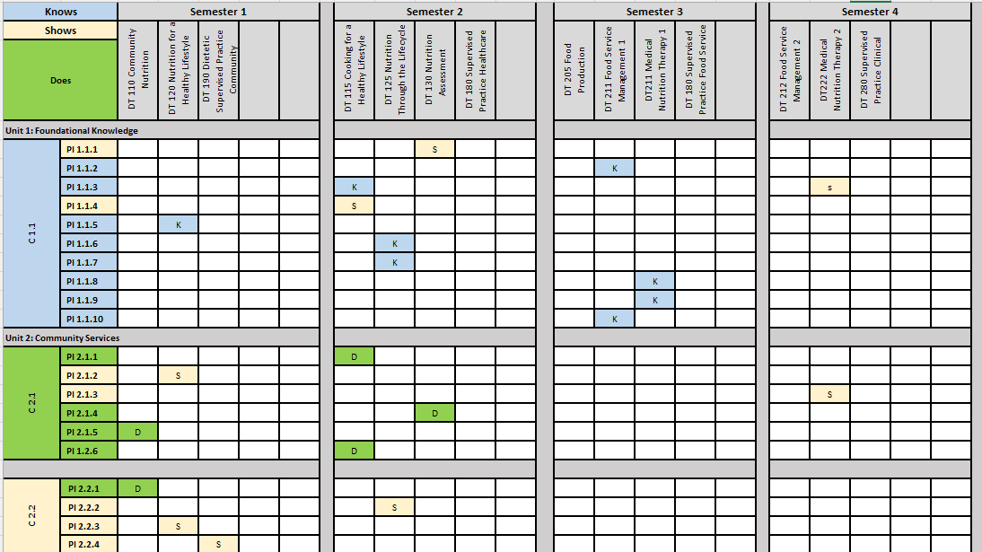

<Name of your program goes here>
Associate Program (including Dietetics Technician DT Option) Curriculum Map (Required Element 3.2)
Courses Aligned with Competencies and Performance Indicators

 |  | Semester 1 |  |  |  |  | Semester 2 |  |  |  |  | Semester 3 |  |  |  |  | Semester 4 |  |  |  |  | Semester 5 |  |  |  |  | Semester 6
  Knows
Shows |  | Course | Course | Course | Course | Course | Course | Course | Course | Course | Course | Course | Course | Course | Course | Course | Course | Course | Course | Course | Course | Course | Course | Course | Course | Course | Course | Course | Course | Course | Course
Does
C 1.1 | PI 1.1.1
C 1.1 | PI 1.1.2
C 1.1 | PI 1.1.3
C 1.1 | PI 1.1.4
C 1.1 | PI 1.1.5
C 1.1 | PI 1.1.6
C 1.1 | PI 1.1.7
C 1.1 | PI 1.1.8
C 1.1 | PI 1.1.9
C 1.1 | PI 1.1.10
C 2.1 | PI 2.1.1
C 2.1 | PI 2.1.2
C 2.1 | PI 2.1.3
C 2.1 | PI 2.1.4
C 2.1 | PI 2.1.5
C 2.1 | PI 1.2.6
C 2.2 | PI 2.2.1
C 2.2 | PI 2.2.2
C 2.2 | PI 2.2.3
C 2.2 | PI 2.2.4
C 3.1 | PI 3.1.1
C 3.1 | PI 3.1.2
C 3.2 | PI 3.2.1
C 3.2 | PI 3.2.2
C 3.2 | PI 3.2.3
C 3.2 | PI 3.2.4
C 3.3 | PI 3.3.1
C 3.3 | PI 3.3.2
C 3.3 | PI 3.3.3
C 3.4 | PI 3.4.1
C 3.4 | PI 3.4.2
C 3.4 | PI 3.4.3
C 3.5 | PI 3.5.1
C 3.5 | PI 3.5.2
C 3.5 | PI 3.5.3
C 3.5 | PI 3.5.4
C 3.5 | PI 3.5.5
C 3.6 | PI 3.6.1
C 3.6 | PI 3.6.2
C 3.6 | PI 3.6.3
C 3.6 | PI 3.6.4
DT C 4.1 | PI 4.2.1
DT C 4.1 | PI 4.2.2
DT C 4.1 | PI 4.2.3
DT C 4.2 | PI 4.2.1
DT C 4.2 | PI 4.2.2
DT C 4.2 | PI 4.2.3
DT C 4.2 | PI 4.2.4
DT C 4.2 | PI 4.2.5
DT C 4.3 | PI 4.3.1
DT C 4.3 | PI 4.3.2
DT C 4.3 | PI 4.3.3
DT C 4.3 | PI 4.3.4
DT C 4.3 | PI 4.3.5
DT C 5.1 | PI 5.1.1
DT C 5.1 | PI 5.1.2
DT C 5.1 | PI 5.1.3
DT C 5.2 | PI 5.2.1
DT C 5.2 | PI 5.2.2
DT C 5.2 | PI 5.2.3
DT C 5.2 | PI 5.2.4
DT C 5.2 | PI 5.2.5
DT C 5.2 | PI 5.2.6
DT C 5.3 | PI 5.3.1
DT C 5.3 | PI 5.3.2
DT C 5.3 | PI 5.3.3
DT C 5.3 | PI 5.3.4
DT C 5.3 | PI 5.3.5
DT C 5.3 | PI 5.3.6
DT C 5.3 | PI 5.3.7
DT C 5.3 | PI 5.3.8
DT C 5.4 | PI 5.4.1
DT C 5.4 | PI 5.4.2
DT C 5.4 | PI 5.4.3

